CloudHook Migration

Step 1) Launching EC2:

- Login to AWS
- Go to https://console.aws.amazon.com/ec2/
- Make sure to select your region as US East (N. Virginia) on the top right corner
- Select the AMIs section on the Left
- Apply the following filters:
  - From drop down, select Public images
  - Platform: CentOS
  - AMI ID: ami-02e684256c85a65af
  - 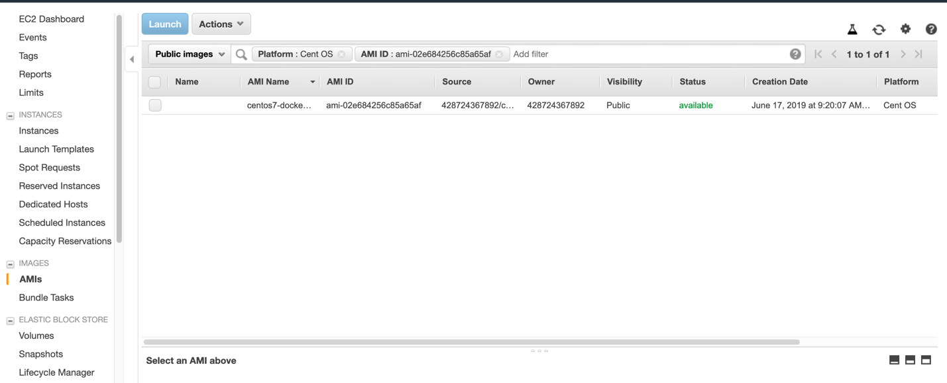

(If S3 bucket is in N. Virginia, please continue. If not, jump to S3 in other regions section)

- Select the AMI and click the launch button.
- Choose instance Type: Select t3a.medium
- Configure Instance Details:
  - Number of instances: 1
  - Network: Select which VPC you want to use. Defaults VPC also will work.
  - Subnet: Choose accordingly.
  - Can leave defaults for rest of the options.
- Storage: Defaults to 510 GB. Change if needed.
- Add Tags: Click Add Tag, Key: Name, Value: <give a name as you need>
- Configure Security Groups: Select as needed. Make sure SSH is opened.
- Review and Launch

(S3 in other regions section)
- First, we have to copy the AMI from N. Virginia to whatever region we need.
  - Select the AMI
  - Dropdown Actions, select Copy AMI
  - Destination region: Select where you S3 bucket is. [EX: US West (N. California)]
  - Click Copy AMI
- Switch to the S3 region from the top right corner
- Select AMIs section on the left
- Select Private images. Clear all filters if any. You should see the copied AMI.
- Select the AMI and click the launch button.
- Choose instance Type: Select t3a.medium
- Configure Instance Details:
  - Number of instances: 1
  - Network: Select which VPC you want to use. Defaults VPC also will work.
  - Subnet: Choose accordingly.
  - Can leave defaults for rest of the options.
- Storage: Defaults to 510 GB. Change if needed.
- Add Tags: Click Add Tag, Key: Name, Value: <give a name as you need>
- Configure Security Groups: Select as needed. Make sure SSH is opened.
- Review and Launch
- When asked for Key: Select the key if you already have one. If not, select create new key. Make sure you have .pem key in your local workstation.

Step 2) Connect to EC2 VM:

- Go to https://console.aws.amazon.com/ec2/
- Select Instances from the Left.
- Look for the newly created instance.
- Select the instance. once the Status Checks are 2/2, click Connect on the top.
- Copy the entire line under Example: it will looks like
  - ssh -i "<your key name>.pem" root@ec2-34-239-153-33.compute-1.amazonaws.com.

- Open your terminal, CD to where you .pem file is and paste the above copied line and hit Enter.
- You should be connected to the Instance.

Step 3) Pre Migration Checks:
- Check whether time is correct by using the following Command:
~ date
  - If timezone is different,
    - ~ timedatectl list-timezones
    - ~ timedatectl set-timezone [TIMEZONE]
  - Reboot the machine
- Check docker service is running or not
~ sudo service docker status

Step 4) Run the Migration Script:
- Cd /root
- Run the migration script called migrate_s3_on_rh7.sh and give the required input data

