Restoring Data in OneDrive for Business
New Functionality: You can now restore folders, sub-folders, or an entire OneDrive for Business Account with a single click.
New User Interface (UI): In response to partner feedback, we have changed the UI to improve usability and streamline the search and restore process. Now, when you open a user account in OneDrive for Business, it will be in folder-view for easy browsing and navigation, and you can perform all your search actions from a single screen.

To restore lost data in OneDrive for Business, navigate to the subscription and click the OneDrive for Business tab.

Search
If there are many users, you can use the search field to find the user whose account you want to search. Then, click the user to open the account in folder-view.
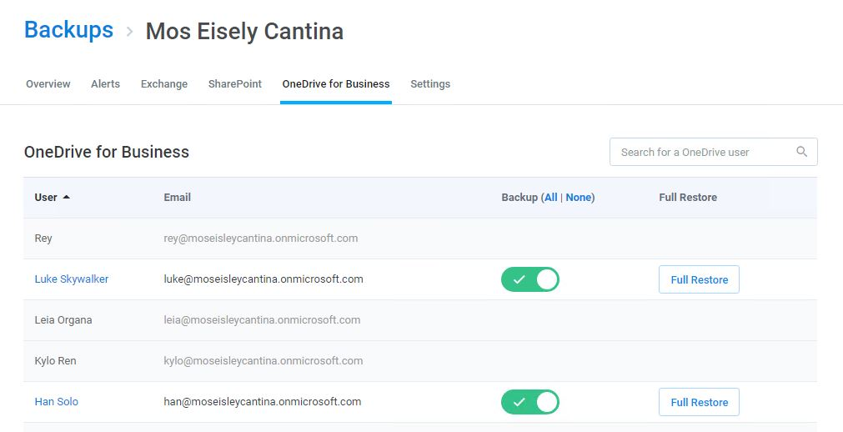

Folder View
From here, you can either enter text in the search field or browse through the folders.
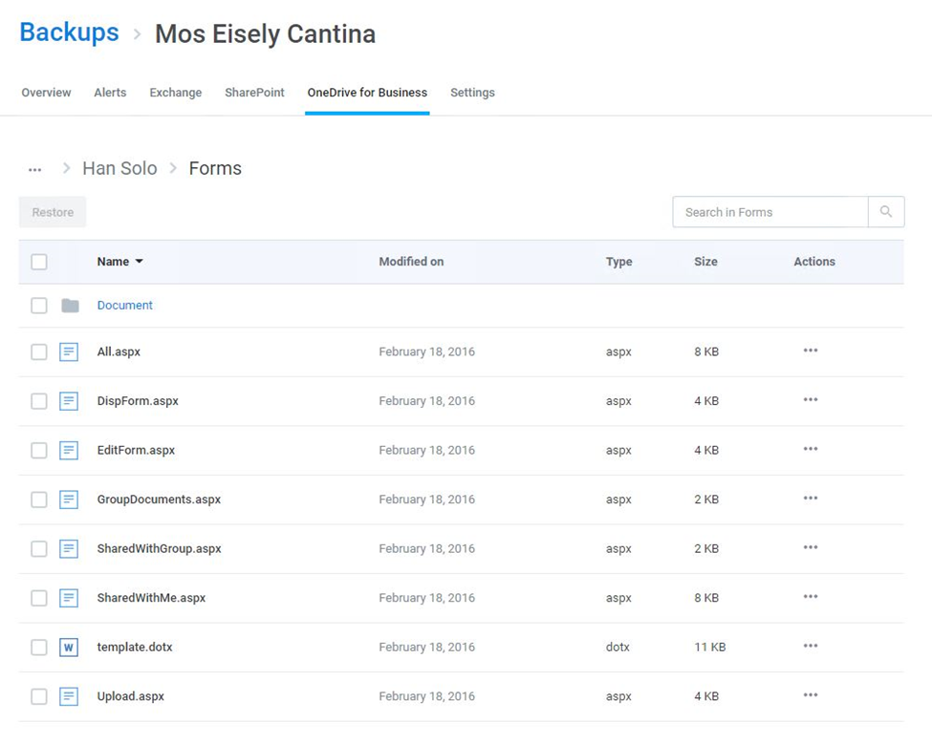

Search to Find
Enter keywords in the folder or file name you are looking for. To ensure privacy, Cloud Backup does not search the content of files.
Cloud Backup also supports a variety of Advanced Search capabilities, including Elasticsearch and Wildcards. For more information, see Advanced Search.
If multiple items appear in your search, you can sort the items by date modified, file type, and size.
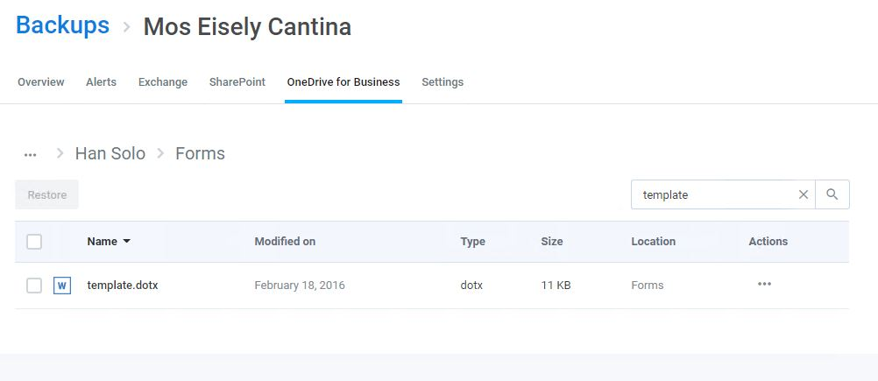

Browse to Find
Click any folder or sub-folder to browse its contents. You can also sort the items in a folder by date modified, file type, and size.
As you drill into folders, your progress and location is tracked at the top of the screen. If you want to navigate back, simply click on the folder path to open a menu, and select the folder you want to return to.
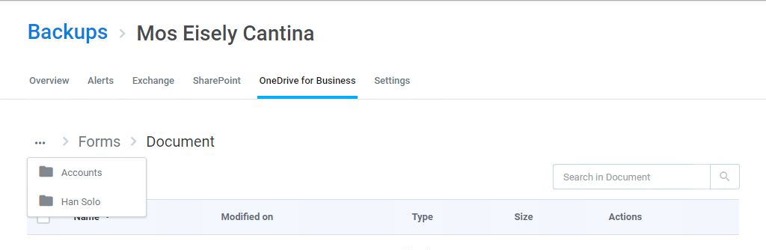

Restore

Individual Item Restore
To restore individual files or folders, select them and click Restore.
Note: You can restore multiple items, including different item types (e.g. files and folders) with a single click.
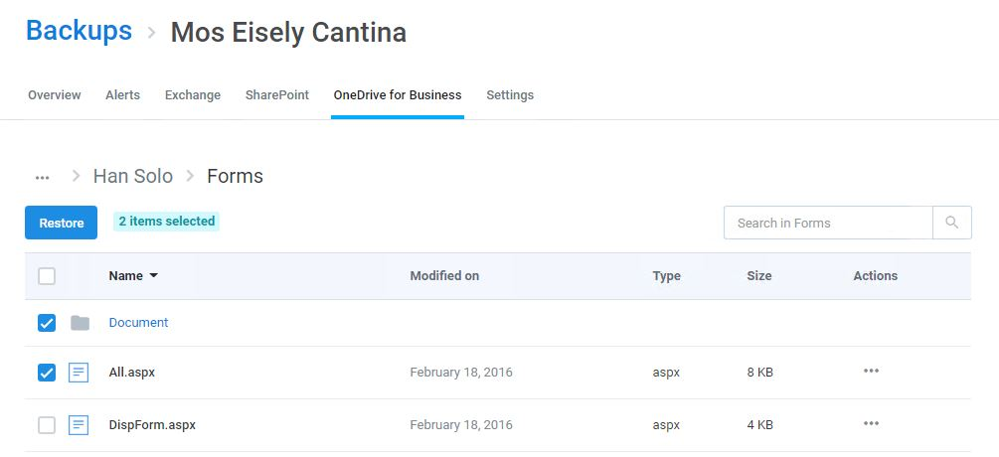
Every OneDrive for Business restoration is a “new item” restore because Cloud Backup does not overwrite existing items. This means that if the item being restored already exists, Cloud Backup will add the restored item back to the site collection with its name appended with a number in parentheses. On the other hand, if the item does no longer exists, Cloud Backup will add the item without appending the name of the file.

Full Account Restore
Cloud Backup also supports the bulk restoration of an entire OneDrive for Business account. This can be initiated on the homepage of the OneDrive for Business tab by clicking Full Restore.
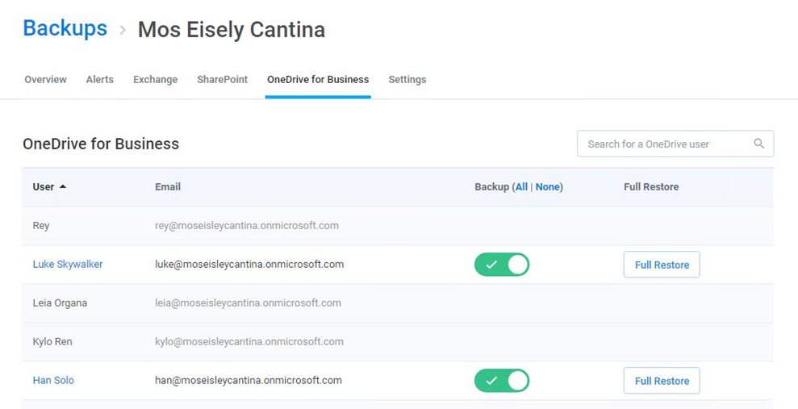
This will open a window with more information about this action. Click Confirm if you want to proceed.
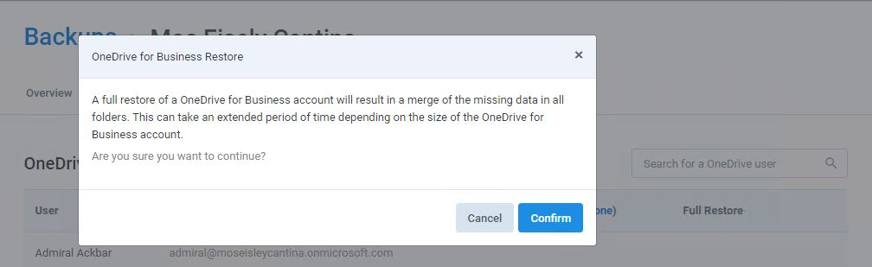
When a full restore is done with Cloud Backup, it is merged with existing content. In other words, the data is de-duplicated before it is inserted into the account. Cloud Backup does not overwrite or delete data at any time.

Previous Version Restore
By default, Cloud Backup will restore the most recent version of a file. However, if versioning is enabled you can restore previous versions. To do so, click the ellipsis (...) under Actions, and click Version History to open a window in which you can select the version you want to restore.
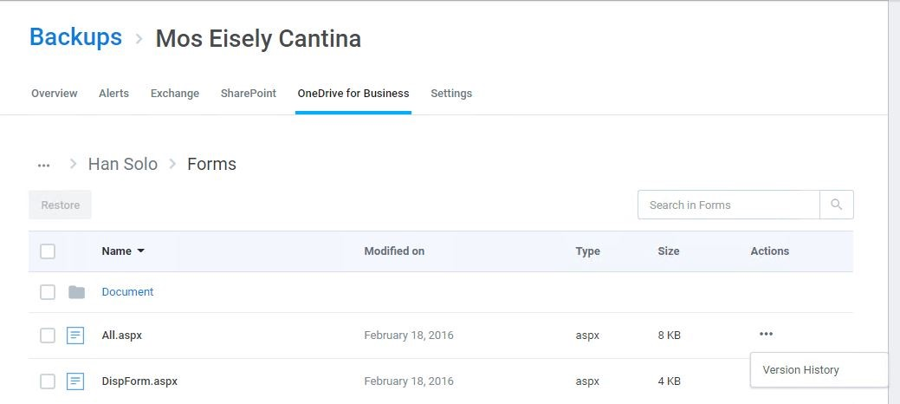
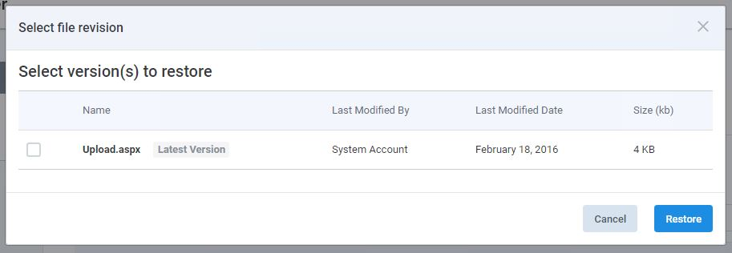

Restore Process
While the restore is initiated with a single click and Cloud Backup makes every effort to restore the content as quickly as possible, the time required to complete the restoration is based on a variety of external factors, including:
- The overall size of the data set being restored.
- Microsoft Office 365 throttling.
- Microsoft Azure throttling.
- The overall availability of Office 365.
During this time, you can view the status of the restore by hovering over the progress indicator next to the mailbox being restored.

