# Office 365 Exchange Data Restoration

|  |
| --- |
| **New User Interface (UI):** In response to partner feedback, we have changed the search and restore UI to improve usability and streamline the data recovery process. Now, when you open a mailbox, it will be in folder-view for easy browsing and navigation through sub-folders, and you can perform all your search actions within a single screen. |

To restore lost data in Exchange, navigate to the subscription and click the **Exchange** tab.

## Search

If there are many mailboxes in the subscription, use the search field to find the mailbox you want to search.

To search a mailbox, click the User to open that user’s mailbox in folder-view.

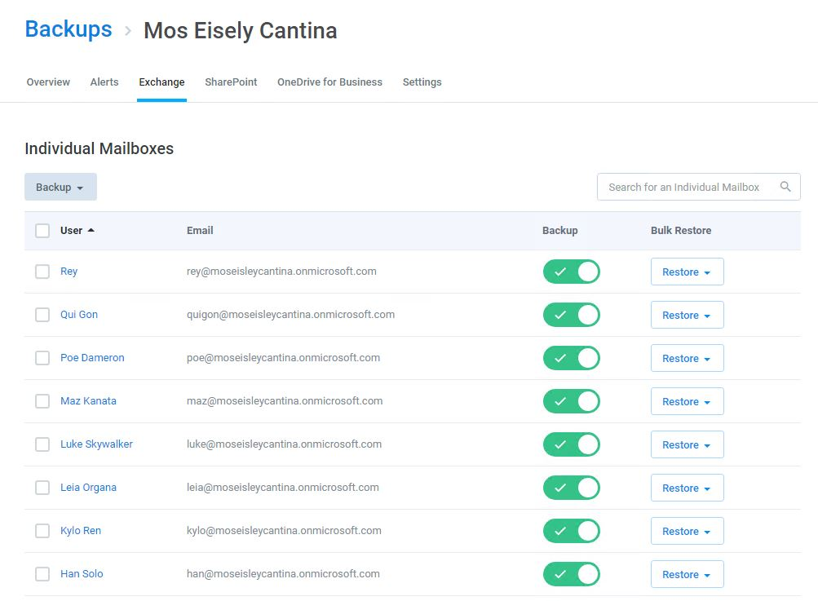

### Mailbox Folder View

From here, you can either enter text into the search field or browse through the folders to find what you want to restore.

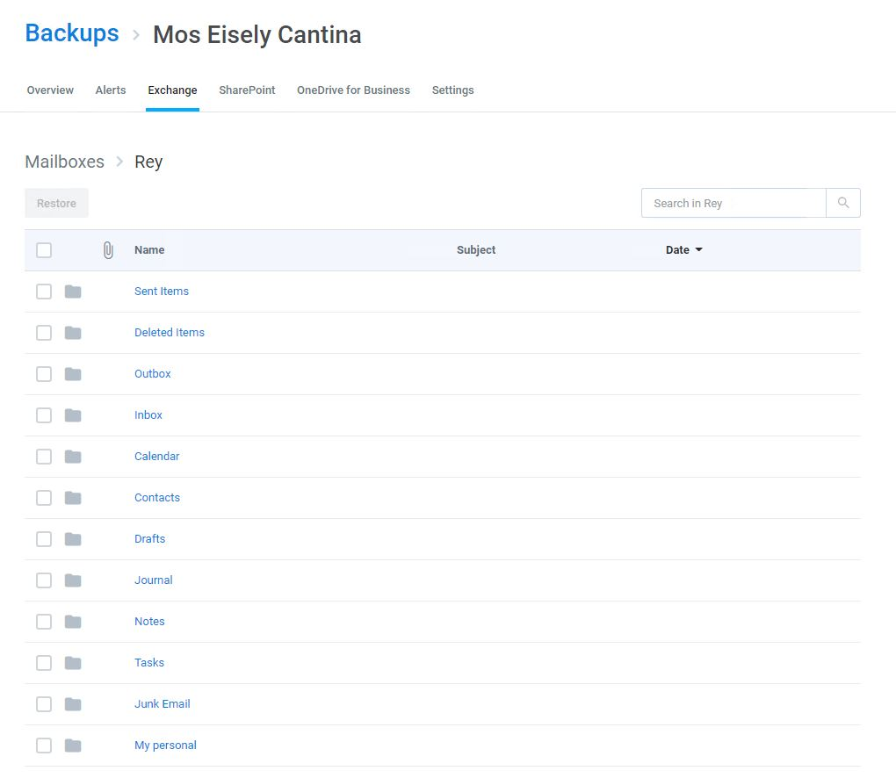

### Search to Find

Enter keywords from the header of the email or the name of the folder you are looking for. Cloud Backup searches the subject line of emails, file and folder names, contact names, and more. However, to ensure privacy, it does not search the body of emails or files.

Cloud Backup also supports a variety of Advanced Search capabilities, including Elasticsearch and Wildcards. For more information, see [Advanced Search](https://support.skykick.com/hc/en-us/articles/219457077-Advanced-Search).

If multiple items appear in your search, you can sort the items by Attachment, Sent by, Subject, and Date.

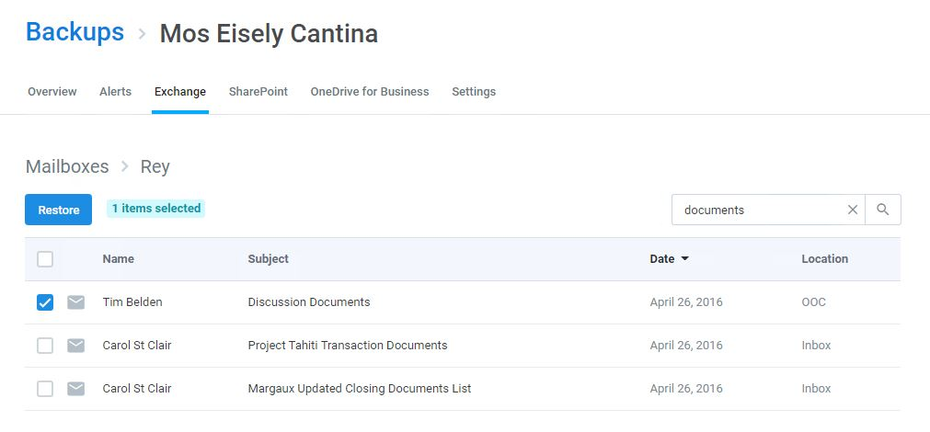

### Browse to Find

You can also click any folder or sub-folder to browse its contents, and sort the items in a folder by Attachment, Sent by, Subject, and Date.

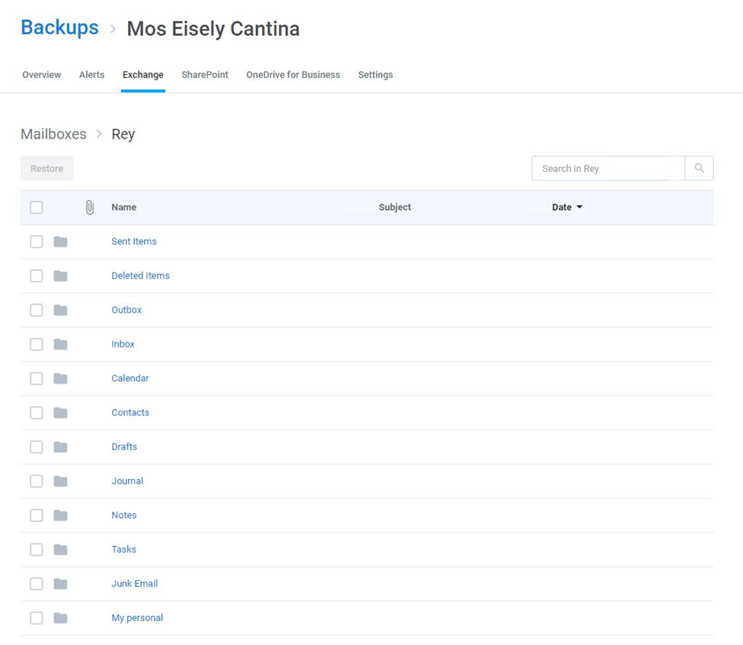

As you drill into folders, your progress and location is tracked at the top of the screen. If you want to navigate back, simply click on the folder path to open a menu, in which you can select the folder you want to return to.

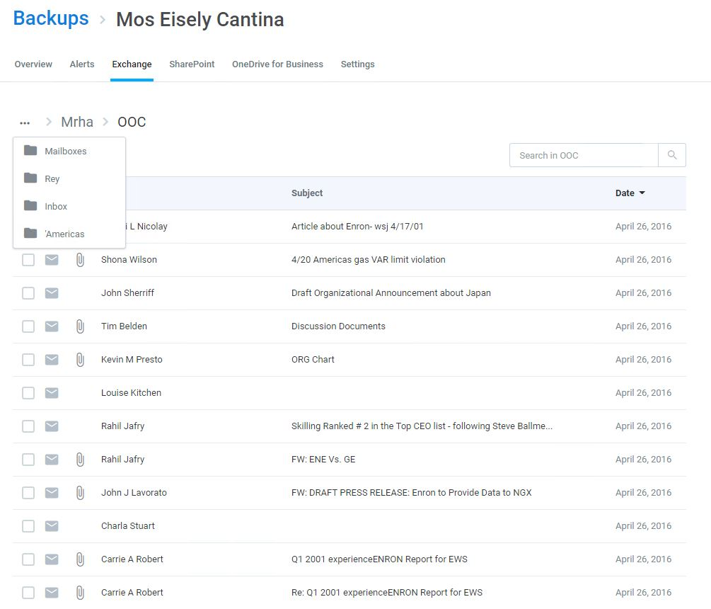

## Restore

### Individual Item Restore

To restore individual folders or items, select them and click **Restore**.



While the restore is initiated with a single click and Cloud Backup makes every effort to restore the content as quickly as possible, the time required to complete the restoration is based on a variety of external factors, including:

* The overall size of the data set being restored.
* Microsoft Office 365 throttling.
* Microsoft Azure throttling.
* The overall availability of Office 365.

During this time, you can view the status of the restore by hovering over the progress indicator next to the mailbox being restored.

### Full Restore

Cloud Backup also supports bulk restore of Full Mailboxes and Calendar, as well as all Contacts, Tasks, Notes, or Journals. On the homepage of the **Exchange** tab, open the **Restore** drop-down menu for any mailbox, and click what you want to restore.

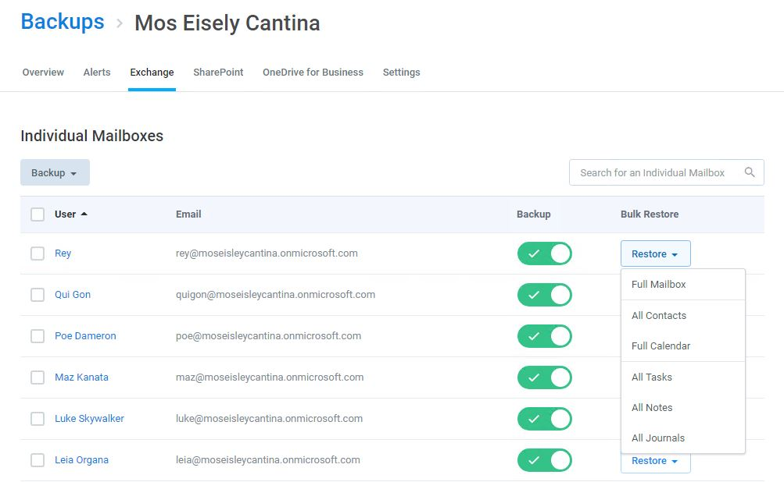

When a full restore is done with Cloud Backup, it is merged with existing content. In other words, the data is de-duplicated before it is inserted into the mailbox. Cloud Backup does ***not*** overwrite or delete data at any time.

While the restore is initiated with a single click and Cloud Backup makes every effort to restore the content as quickly as possible, the time required to complete the restoration is based on a variety of external factors, including:

* The overall size of the data set being restored.
* Microsoft Office 365 throttling.
* Microsoft Azure throttling.
* The overall availability of Office 365.

During this time, you can view the status of the restore by hovering over the progress indicator next to the mailbox being restored.

### Restoring a file when a folder has been deleted

Cloud Backup will re-create the folder architecture and restore the file in that recreated folder architecture. However, if someone has deleted the site collection, the Global Admin will need to recreate the site collection manually before hitting restore on the file.

### Restoring mailbox data after a user leaves and their Office 365 subscription is deleted

Cloud Backup will not delete the backup of the mailbox, and the content will be retained for the duration of the retention period (as indicated in the Settings section of an Office 365 Backup subscription). If the Office 365 license has been removed (thus deleting the mailbox from Office 365), this will trigger an alert titled: Backup [mailbox] not found. To address this alert you will need to disable the backup for the mailbox. Once the mailbox is disabled, you will no longer be charged for the mailbox and the alert will not pop up again.

In order to maintain the integrity of the mailbox, while removing the need to have it licensed, Microsoft’s best practice is to convert the mailbox to a Shared Mailbox first, and then remove the license. By doing this, instead of simply removing the license and deleting the mailbox, no mailboxes will need to be created if the customer wants to restore the data. The backups can still be turned off for that mailbox, resulting in no further charges.

**Note:** Disabling the backup of a mailbox will ***not*** delete the backed-up data. Search and restore is available while the subscription is active.