Loading registry hive from recovered system to enable storage drivers.
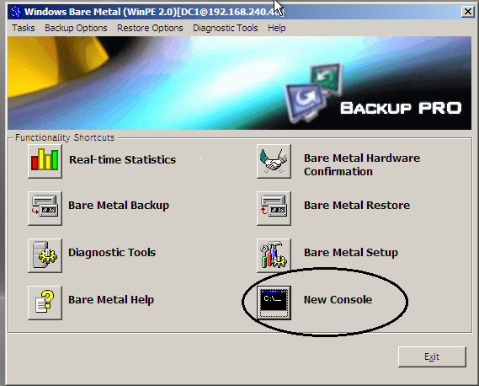
Restore the system through normal Bare Metal Restore procedure. After the restore is done select New Console.

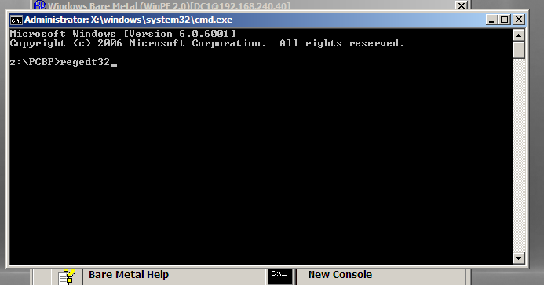
Load registry editor.

Highlight HKEY_LOCAL_MACHINE .
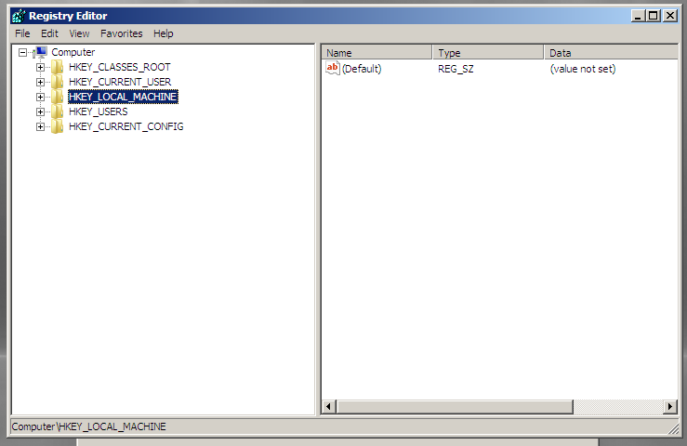
Select File and Load Hive.
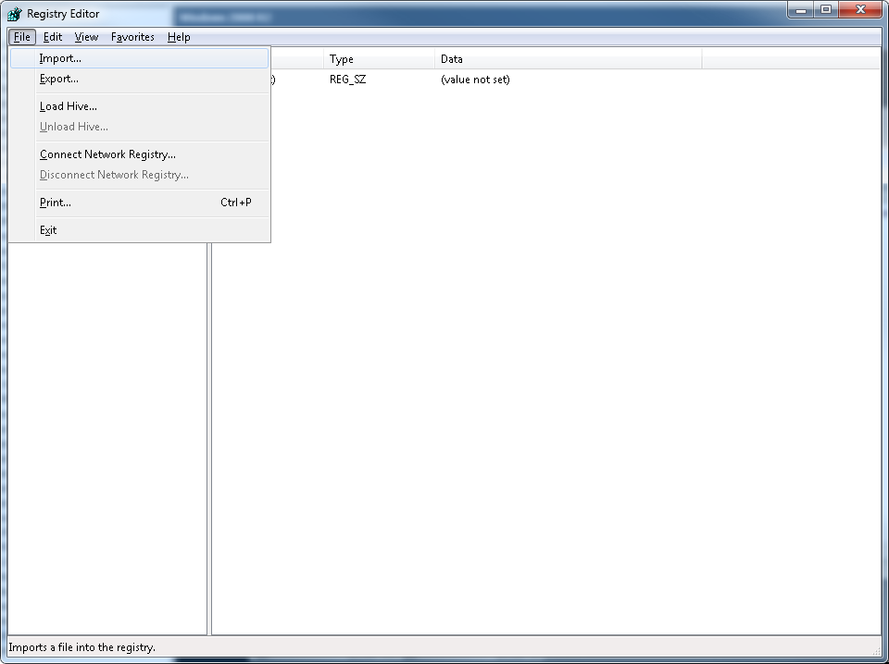

Load the system hive, located by default in C:\Windows\System32\Config\SYSTEM.
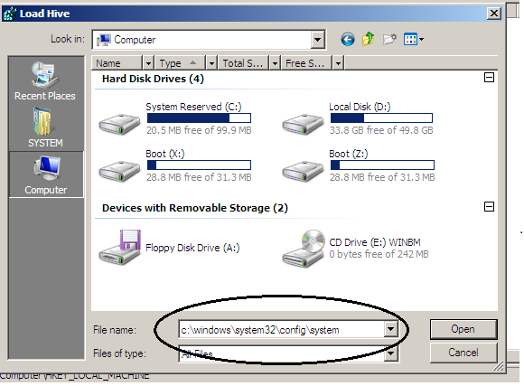

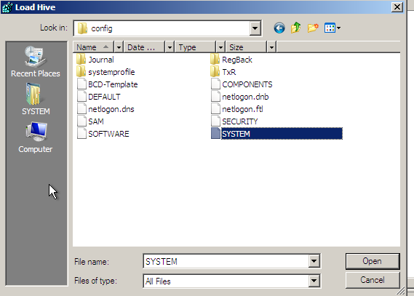
You will be asked to give the hive a name, any name will do. I used unitrends in this example.
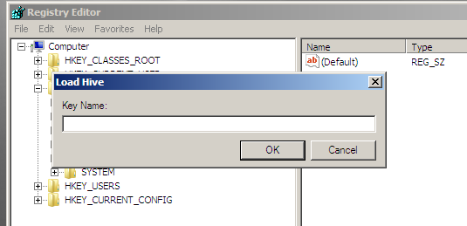

As you can see below the hive is showing up under Unitrends.
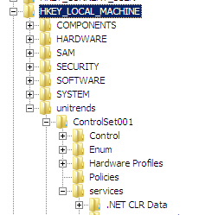
Navigate to HKEY_LOCAL_MACHINE\unitrends\ControlSet001\services\
Under services you will find arc and arcsas like shown below.
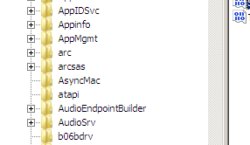

Change the start value .
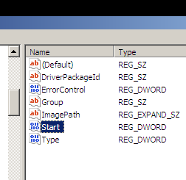
In my system the original value was 3, make the value 0.
