Considerations when recovering a multi-server farm
When you prepare to recover a farm, be aware of the following issues:
- You cannot restore a multiple-server farm to a stand-alone farm or a stand-alone farm to a multiple-server farm.
- You cannot back up from one version of Microsoft SharePoint Server software and restore to another version of SharePoint Server software.
- When you restore the farm by using Microsoft SharePoint Server, the restore process will not automatically start all of the service applications. You must manually start them by using Central Administration or Windows PowerShell. Do not use SharePoint Products Configuration Wizard to start the services because doing so will also re-provision the services and service proxies.

Restore application services and search service in SharePoint Server
It is expected behavior during a SharePoint restore for some of the SharePoint services to not start automatically after a restore has completed. This will appear as an error when really it should be a warning to reset the Service credentials. This almost always occurs in multi-server Farms in which Domain Accounts are used by the services. This can be corrected by opening the Central Administration tool editing the configuration, re-entering in the Domain credentials and manually clicking to start the services. The most commonly observed services exhibiting this behavior are the Search Service and the Web Analytics Service.

Manually Reset SharePoint Services through the GUI
Open the Central Administration Web GUI
Start > Microsoft SharePoint 2010 Products > SharePoint 2010 Central Administration
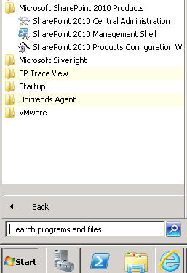

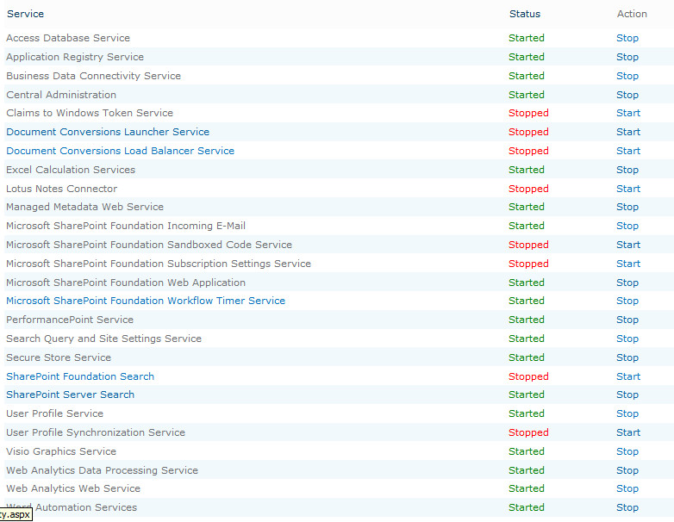
Claims to Windows Token Service needs Admin to click > Start
The Document Conversion Launcher Service requires Admin to click > Start then make a selection of the Load Balancer Server and Click OK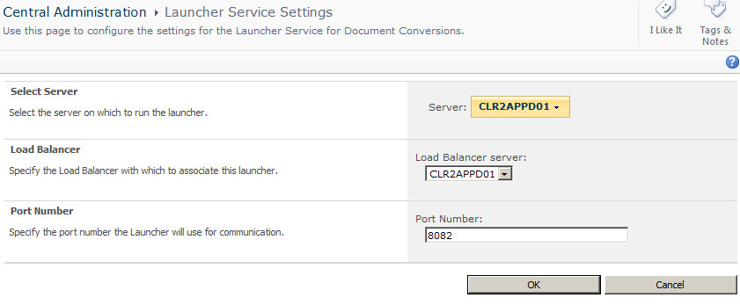

Document Conversion Load Balancer Server needs Admin to click > Start
We don’t use the Lotus Connector and don’t have the Lotus Client .
Therefore we do not have the Lotus Notes Connector Service Started.
Installing the Client, having a Notes ID file and the Notes Password are required to configure and start this optional service.
Entering a Application Pool and installing the Notes Client is required
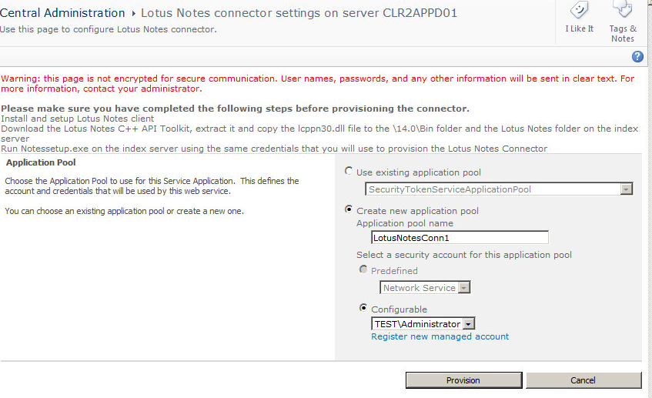
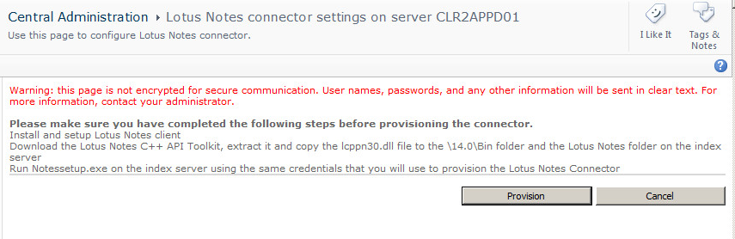
Microsoft SharePoint Foundation Sandboxed Code Service needs Admin to click > Start
Microsoft SharePoint Foundation Subscription Settings Service needs Admin to click > Start

SharePoint Foundation Search Service needs the Admin to enter in the Content Access Account Credentials and then Click Start to Start the Service
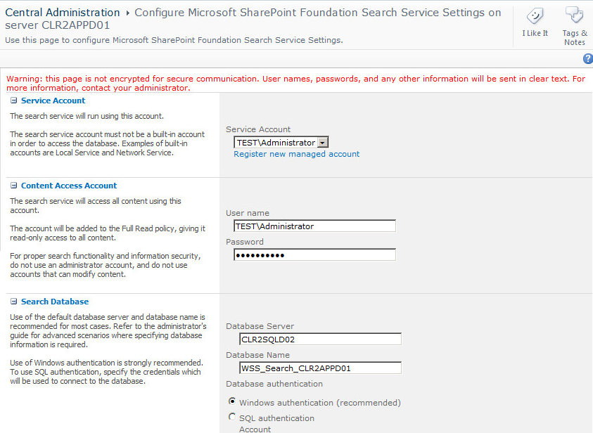
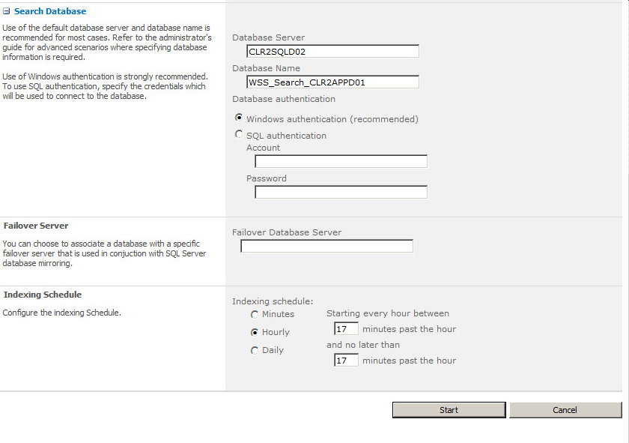

Note: The Search Service will take a few minutes of processing to Start
User Profile Synchronization Service requireds Admin to enter Service Account Name and Password and to Click OK to Start the Service.
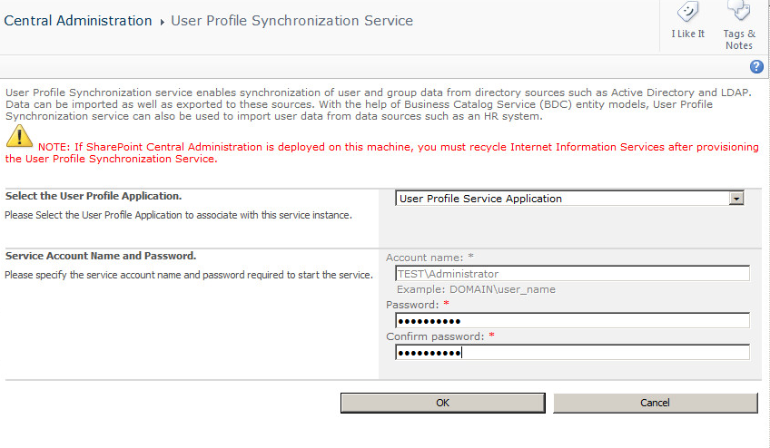
Final Service Status
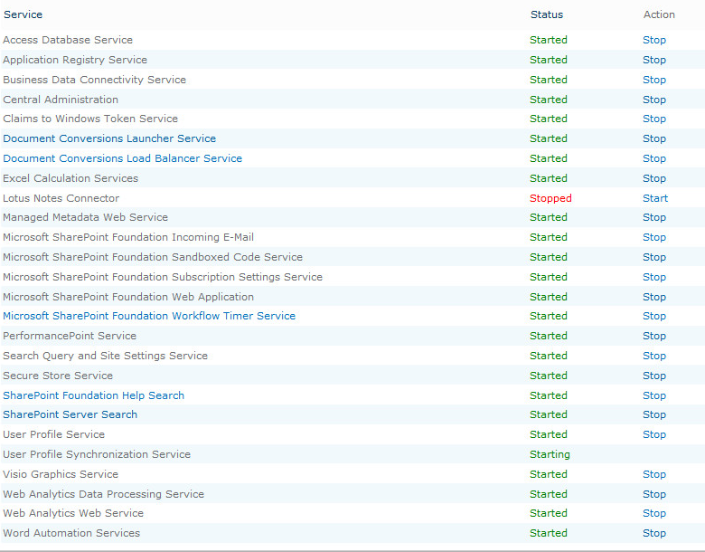
Note: We don’t use the Lotus Connector and don’t have the Lotus Client .
Therefore we do not have the Lotus Notes Connector Service Started.
Installing the Client, having a Notes ID file and the Notes Password are required to configure and start this optional service.

After restore is complete and services are reset, the administratorshould perform and iisreset on any Web servers to restart SharePoint

References:
Restore a farm in SharePoint Server 2010
Restore a service application in SharePoint Server 2010
Restore search in SharePoint Server 2010

